**I’m Nicholas Musau**

**I’m best defined as: Business Performance and Productivity Analyst, Credit Risk Analyst or**

**Finance analyst and Strategist**

I specialize in Data Science, Data Analysis Consulting, with a passion for unearthing insights from complex and ambiguous data for social-economic benefits across industries. Nicholas is adept at implementing the full-cycle of data analysis extending from collection and cleansing to modeling and implementation. My ability to do it all frequently distinguishes my data skills from those of competitors.

**About**

With experience in banking and finance, I’m highly analytical, with advanced problem solving, analysis, financial modelling and reporting skills. Often I work with large volumes of data from various types of databases, when handling Data analytics, or Business performance and productivity analysis projects. As a self-starter, I independently understand problem statement, identify data sources, plan project scope, design the analysis process, data modelling, perform ETL designs, Business Intelligence visualizations and execute the project to the end.

I have niche in business acumen, so I can combine multiple skills and tools to ensure cost effective, efficient process while maximizing the profit.

My involvement in any project leads to lowering CIR, realizing RIO, for better investment decisions.

**Mission**

My mission is to contribute to the overall objective of my customers to achieve competitive advantage by use of innovative techniques on quality collected data for data driven decisions.

**Vision**

1. Provide customers with quality data results done with advanced statistical analysis,
2. Offer an extensive range of data analysis services to help customers come up with competitive data-driven business decisions

**Why hire me?**

1. I offer on-time delivery
2. Ensure original quality work delivery
3. I’m keen on data and project integrity for customers
4. Subject matter expertise
5. Timely communication

We collect, prepare, and clean data for data science and machine learning models. Dataconsultants work with data science departments and AI companies to collect, and prepare dirty to make it useful in machine learning models. We focus on doing dirty work of data collection/mining, data cleaning, data entry, data analysis, and data annotation.

By our specialization, we allow data science teams to focus on developing accurate ML models while asking themselves relevant business questions, and formulating business decisions for a thriving, intelligent data driven business.

We ensure quality, satisfaction and timely delivery to our clients

***Education and Certifications***

***Bsc Business Information Technology:*** *Jomo Kenyatta University of Agriculutre and Technology*

***Diploma of Information Technology:*** *Jomo Kenyatta University of Agriculutre and Technology*

***Certified Information Security Manager (CISM) Certified:*** *Charles Sturt University*

***Certified Information System Security (CISSP) Certified:*** *Charles Sturt University*

***Data Scientist Mastery:*** *IBM Corporation*

***GDPR Data Protection Officer Certified:*** *University of Derby*

***ICSI|CNSS Certified Network Security Specialist:*** *Certified International Cybersecurity Institute*

***Project Management Professional (PMP) Certified:*** *Charles Sturt University*

***VMware vSphere 6 Certified:*** *Charles Sturt University*

***Cloud Models, Architecture and Risk Management Certified:*** *Charles Sturt University*

***AWS Cloud Practitioner AWS***

**Basic Skills**

Python, SQL, MySQL, SQL Server, Excel, Tableau, PowerBI, Amazon QuickSight, Amazon S3, Amazon Redshift, DynamoDB and Aurora, Open Data Kit (ODK)

**Portfolio**

**Impact of Economic Inflation in Africa**

**Business Problem**

An investment company XYZ, wanted an expert to use analytical skills to evaluate the performance of African Countries’ GDP over the years. A business analyst would help the company ***identify opportunities of investment, discover performance of the existing investment and reduce the time taken every time they want to understand the business performance***. The management could use the solution in product rating and reviews, while developing metrics for continuous product improvement. Advanced data preparation and modelling skills were required to automate the repetitive process by creating interactive dashboards and reports. The final solution would have a positive impact to the management in that, decision makers can make informed decisions on the strategies to build economic development activities for the general country growth and sustainability.

**Approach**

The initial step was business understanding and project requirements then collect the required data. Secondly, I planned a design direction while reviewing the design and specifications for changes that affect respective modules. I could propose the best analytical software for the project and work closely with cross-functional teams for product enhancement to ensure project controls are in place.

**Solution**

With deep analytical background, and skills in business intelligent tools I created an automated Tableau dashboard for the state of African economy while paying attention to details and specific business questions. My ability to make a positive business impact by developing real-time reports enabled XYZ Company to make data driven investment decision to shape the future with low risk.The solution saved the company 40 percent of the time used every month in this analysis, and saved 56 percent losses incurred in unprofitable investments. The annual financial reports recorded an increase of 6 percent profits from 3.7 percent of the previous year.

[**https://public.tableau.com/app/profile/nicholas7429**](https://public.tableau.com/app/profile/nicholas7429)

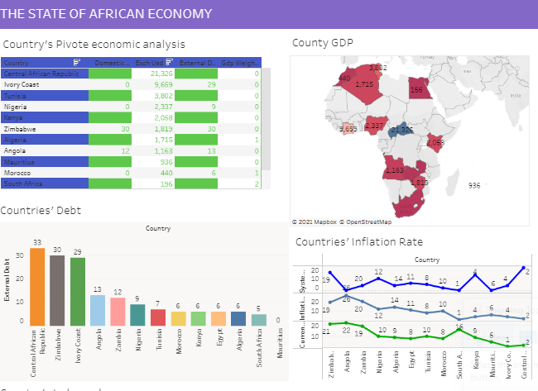

**Nick’s Cookie Sales**

**Business Problem**

Nick has an online cookie shop which recently has grown to attract customers from different countries. All the customer, and sales data is available in the database. To remain competitive in a fast-phased industry of cookie sale Nick wanted ***to enhance efficiency by understanding customer preferences and experience, identify the profitable cookies, track the daily units sold in an automated manner.*** While the problem requires deep analytical mind to lead to timely and insightful financial reporting of financial metrics, the solution ought to be cost effective. The goal is to automate the profit dashboard with accurate data, meaningful analysis and interactive charts which leads to business improvement, operational efficiency and cost reduction.

**Approach**

As a self-starter, I independently understood the problem statement, identified data sources, plan project scope, and design the analysis process. I came up with the appropriate tools to achieve the business objective. Experience in SQL for data extraction from the database then creation of ETL pipelines to analytics software was the most cost effective approach. The utilization of automated Excel dashboards helped in developing scalable and efficient processes to support operations. The problem required advanced skills in excel with advanced problem solving, modelling and reporting skills. The final solution could help to derive insights for organizational profitability.

**Solution**

The final product was a commercially successful automated Excel dashboard which answered multiple business questions in an economical manner. The solution delivered real value for the identified market segment because Nicholas could identify the best markets to concentrate on and the best customers to give discounts on purchase. Additionally, he could refine customer value proposition and competitive positioning for his cookies. The developed solution helped the company to become more profitable by reduced costs, increased revenues and improved organizational efficiency.

1. **Nick’s Cookie Sales Analysis**

[**https://onedrive.live.com/view.aspx?resid=3AB33DB1F0BBBB23!2439&ithint=file%2cxlsx&authkey=!AMmGHo-CkMN1_kI**](https://onedrive.live.com/view.aspx?resid=3AB33DB1F0BBBB23!2439&ithint=file%2Cxlsx&authkey=!AMmGHo-CkMN1_kI)

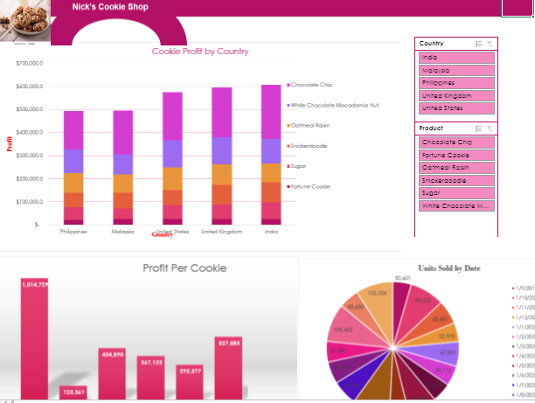

1. **Performance Appraisal (DS)**

Predict Customer Lifetime Value (basic) dataiku – put this in Jupyter dashboard view add-on, JupyterLab.

1. **Customer Satisfaction analysis- SQL**

**Community Participation**

AWS Community Builder- with other experienced technology experts, influencers, and thought leaders who voluntarily offer their support to developer communities, companies, and tech-enthusiasts by training, speaking at events, mentoring, and publishing content.

(<https://aws.amazon.com/developer/community/community-builders/> )

AWS Educate Student Ambassador- I organize both hands-on and knowledge sharing Meetups to train students, and AWS Cloud enthusiasts on AWS cloud services. (<https://aws.amazon.com/education/awseducate/student-ambassador-program/> )

Deeplearning.ai Ambassador- I organize Pie & Ai Meetups to train and share knowledge of developments of Artificial Intelligence to deep learning communities. More than 2000 attendees have benefited from our events. (<https://www.deeplearning.ai/ambassador/> )

**Applied Science (Publications)**

A Review of Predictive Analytic Techniques for Diabetes Prevalence. By: Nicholas Musau, Josiah Ochieng Kuja (<https://innspub.net/ijbb/review-predictive-analysis-techniques-diabetes-prevalence/> )

Technology Behind Low Cost the Development of a Low-Cost Spectra Imaging for Early Disease Analysis in Crops. By: Bronson Eran’ogwa, Masibo Thomas, Elias Baya and Nicholas Musau (<https://www.researchgate.net/publication/337669675_Technology_behind_the_development_of_a_low-cost_spectral_imaging_for_early_disease_analysis_in_crops> )

Assessing the impact of soil variability conditions to crop production using Artificial Intelligence: (Informatics for BioEconomy in Africa) Nicholas Musau, Christopher Wanjohi, Joshua Ndeleva, Josiah Kuja. (*Under Review*)

**Contact**

E-mail: [nichmsau@gmail.com](mailto:nichmsau@gmail.com)

**Services**

1. Business performance and productivity analysis -

Nicholas experts committed to working with a range of industries like Finance & Insurance, Retail, Restaurant, Marketing, Agriculture, Transportation, Energy, Health Care, Education, Manufacturing, legal to enrich machine learning models with accurate data for high performing models. My mission is to help businesses get best inferences from their data by doing the dirty work of data collection, data cleaning and data annotation. I can facilitate Business Efficiency through Cost Reduction, Risk Analysis, Strategies to Optmize business processes, improve business worth by improved customer retention, satisfaction, and loyalty, market analysis for ROI) and improvement of CIR. Perform Process Improvement through Analytical Process Automation, Operational Strategy, via Performance review for risk identification. Business process optimization with finance functions deliver technology change and delivering end to end finance data management solutions. Let’s get in touch

1. Financial modelling & Interactive Reporting Info-graphics-

This analysis helps businesses stay profitable, and determines revenue growth, profits, operational and capital efficiencies. It also evaluates economic trends and supports businesses in developing successful, long-term financial plans. My proficiency in Excel, SQL, Python and Business Intelligence tools like Tableau and PowerBI helps me perform data and financial analysis very fast while being keen to customer details. I can create various financial modeling techniques, like sensitivity analysis, predictive models, scenario analysis, linear regression, time series models and logistics regression to create forecasts, and improve existing models. The results are displayed for high-level executives with tools like decision tress and insightful infographics for easier interpretation and decision making. Let’s get in touch

1. Develop product performance KPIs –

Any business would need KPIs for Performance measurement frameworks Quality control assessment. This job needs an expert to appraise and recommend improvements to current business programs, propose new techniques and technologies to actualize business goals. Performance and productivity analysis will involve research, collection of the right data to better analyze outcomes. Productivity enhances competitive advantage for a company by raising value-added content of its services and products faster than the competitors. Performance and productivity analysis shapes the re-investment strategies of a company, create better value to its customers, and increase customer experience. Let’s get in touch

1. Credit Risk Analysis – With full understanding of financial risk, decision science equipped with vast knowledge of domain knowledge give me a hedge in risk management. I will help you get insightful risk leadership and a commercial yet independent approach to manage risks. I conduct routine predictive data analysis to support underwriting optimization, and the existing audit of existing underwriting strategies. With proficient written and communication skills iced with advanced problem solving skills I can think creatively to perform data analysis to monitor, measure, and manage risks. Further I own strong analytical and programming skills with tools like Python, SQL, Excel to develop risk analysis solutions that supports management in monitoring credit or operational risk.

By leveraging analytical tools, I perform data collection, analysis and reporting of the credit risk KPIs like vintage losses rates, delinquencies, application conversion to monitor and communicate customer loan portfolios. Let’s get in touch

**Blog**

Forming Data Teams

Data Strategy

Cloud Adoption

Blog

**Contact Us**

**Fill a form** [Business Efficiency Consulting Services with Andrew Jensen](https://www.andrewjensen.net/business-efficiency-consulting)

**Our Commitment and Integrity**

Dataconsultants commit to offering quality services, at the required time, under the stated specifications while observing data confidentiality, integrity and privacy. We ensure satisfaction to our clients.

Name, Email, Choose service, Describe your requirements, Set specific requirements, Submit.

Pricing model

Root cause analysis

**Introduction**

Food security systems in Kenya have yet to be implemented to satisfaction. Reports and real life experiences display humans and animals suffering from acute hunger in various parts of the country.

**Problem Definition**

The approach towards food insecurity mitigation need more robust interventions for realization of better results. 12300 humans died, 32000 children suffer malnutrition, more than 4503200 livestock died due to increased drought and 34000 wild animals died while other come out of their range lands to eat farm crops. Such situation results into human verses wild animal conflicts. In such a situation a need for urgent and more advanced solutions need to be implemented.

**Improved Problem-Solving Approach (IPSA)**

This approach focus on enhanced impact, sustainable results and

Now, my approach to the current hunger challenge in a bit different, more comprehensive in a manner that it takes into consideration inter-desplinary skills, knowledge, and approaches to address the hunger problem. I use the skills and of a professional project manager who leads throughout the project development lifecycle. He/she will budget, schedule and tracking a project plan using Kanban board, Gantt charts Project management tools. A clear explanation of the project plan and its’ execution will be presented and includes a budget, timeline, schedule, roles and responsibilities among other things. I will lead the project to successful completion. Before starting I ensured the plan is sound, the tracked the project to ensure that its execution stays within the approved budget and schedule.

**Expected Impact**

The project is expected to improve the lives of 23000 kenyans and save 45000 livestock and promote peace and reconciliation in the community. Conflict resolution experience

**Suggested Solution**

For the current problem, I will develop a real-time disaster monitoring tool using Google Earth Engine cloud platform. The system development will be developed under the project management guidelines, and principles. While there are no stakeholders to report to, I implemented the project with consultation with cross-functional teams like technical experts, research professionals, policy makers and society stakeholders whose input guided in the project development and success. I could define the project scope, goals and deliverables. Tasks and required resources. While I led the project I teamed with Chris who made the front-end website.

**Objective**

1. The suggested solution will address the below objectives
2. Develop a visualization graph
3. Predict the expected rains
4. Intergrade the external data with Google Earth Engine data

**System Development Design**

**Results**

The development of Drought monitoring tool lead to ensuring customer satisfaction because the project was aligned product development with business goals.

Lead quality assurance

Monitor and report on project progress

Present to stakeholders reports on progress as well as problems and solutions

Implement and manage change when necessary to meet project outputs

Evaluate and assess the result of the project

Project planning, risk management, time management and other project management skills

Project management qualification (PMP), Certified Associate in Project Management (CAPM), or equivalent experience as a project manager

Experience in strategic planning, risk management and/or change management

To be included

• Proven track record of managing all aspects of a successful product throughout its lifecycle

• Proven ability to develop product and marketing strategies and effectively communicate recommendations to executive management

• Solid technical background with understanding and/or hands-on experience in software development and web technologies

• Strong problem solving skills and willingness to roll up one’s sleeves to get the job

• Skilled at working effectively with cross functional teams in a matrix organization

• Excellent written and verbal communication skills

* Performing customer interviews and market assessments
* Translating business requirements into technical specifications and vice versa
* Planning and designing product roadmap
* Allocating resources
* Running design sprints
* Prioritizing product features and communicating the reason behind this to the stakeholders
* Pricing and revenue modeling
* Defining and tracking success metrics
* Communicating effectively with all stakeholders
* Ensuring timely completion of the product without cost overrun
* Gathering customer requirements
* Assessing market demand
* Ideating and planning a winning product
* Defining product strategy
* Budgeting, team creation and resource allocation
* Drawing up the product roadmap
* Converting business needs into technical specifications for engineers to understand
* Communicating with all stakeholders
* Planning for and allocating resources
* Creating pilot programs to run prototypes and assess outcomes
* Taking evidence-based decisions
* Aligning product development with business goals